Strategy Method

The strategy method is Behavioral Design pattern that allows you to define the complete family of algorithms, encapsulates each one and putting each of them into separate classes and also allows to interchange there objects. It is implemented in Python by dynamically replacing the content of a method defined inside a class with the contents of functions defined outside of the class. It enables selecting the algorithm at run-time. This method is also called as Policy Method.

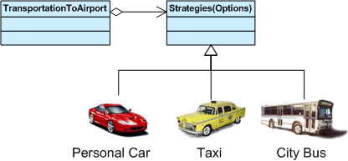

Problem without using Strategy Method

Imagine you created an application for the departmental store. Looks simple? Initially, there was one and only one type of discount called the On-Sale-Discount. So. everything was going with ease and there was no difficulty for maintaining such a simple application for a developer but as time passes, the owner of the departmental store demands for including some other types of discount also for the customers. It is very easy to say to make these changes but definitely not very easy to implement these changes in an efficient way.

Solution using Strategy method

Let’s see how can we solve the above-described problem in an efficient way. We can create a specific class that will extract all the algorithms into separate classes called Strategy. Out actual class should store the reference to one of the strategy class.